Types of Mixtures
What is a mixture?
__________, __________, __________, __________, and _____ are not pure substances but are ____________.

A mixture is made from ______________________________________ that have been stirred together.
____________________________________________________________________________
For something to be a mixture, __________________________________________________.

Solutions
When __________ is stirred into __________, the sugar ____________.
The __________ sugar breaks up into __________________, too small to see and __________ into the water.
Although the sugar can’t be seen, you can tell it is still there because you can _____________.
A substance that dissolves is said to be __________.
An example of a soluble substance is _______.
A substance that doesn’t dissolve is said to be __________.
An example of an insoluble substance is _______.
When you stir sugar into water, you make a ____________________.
The substance that dissolves is called the __________. In this example, the __________is the solute.
The substance that dissolves the other one is called the __________. In this example, the __________ is the solvent.
For each of the following solutions, identify the solute and the solvent.
Solution | Solute | Solvent
Seawater
Black coffee
Soft Drink
Properties of Solutions
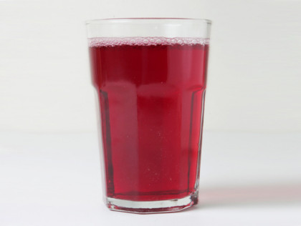
Light passes easily through solutions. They are __________________ and __________.
Solutions can be ________________ or ________________.
Seawater is a ________________ and __________ solution.
Cordial is a ________________ and __________ solution.

Concentration
Concentration is a way of measuring the amount of ________________________ in a ____________.
If there is a lot of solute dissolved, then the solution is ______________________.
Is there is only a little solute dissolved the solution is __________________.
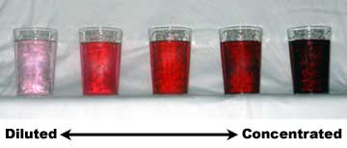

An example of a concentrated solution is __________________________________________.
Before you drink the cordial, you need to __________________________________________.
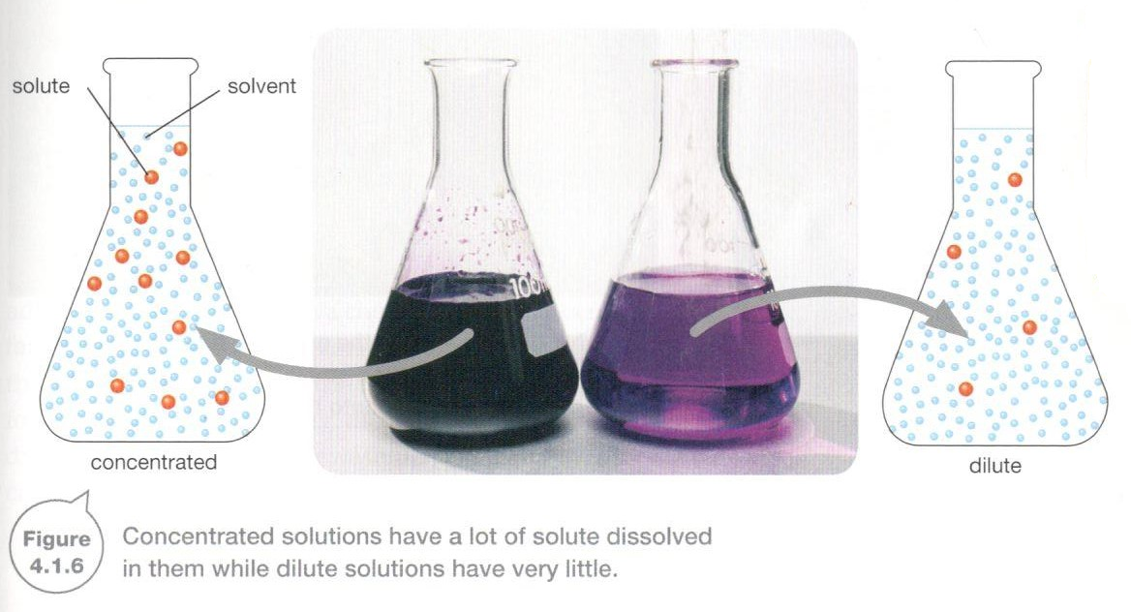

Suspensions
A suspension is a mixture made when one substance doesn’t dissolve in the other and separated id left to stand.
An example of a suspension is a mixture of sand and water. The sand settles to the bottom when it is left.

